**Test Case**: - Emergency Change State flow from New to Closed.

Login to ‘https://pdsinfosysliveopsdemo2.service-now.com/’ with valid credentials



Navigate to ‘Change > Create New’ from the filter navigation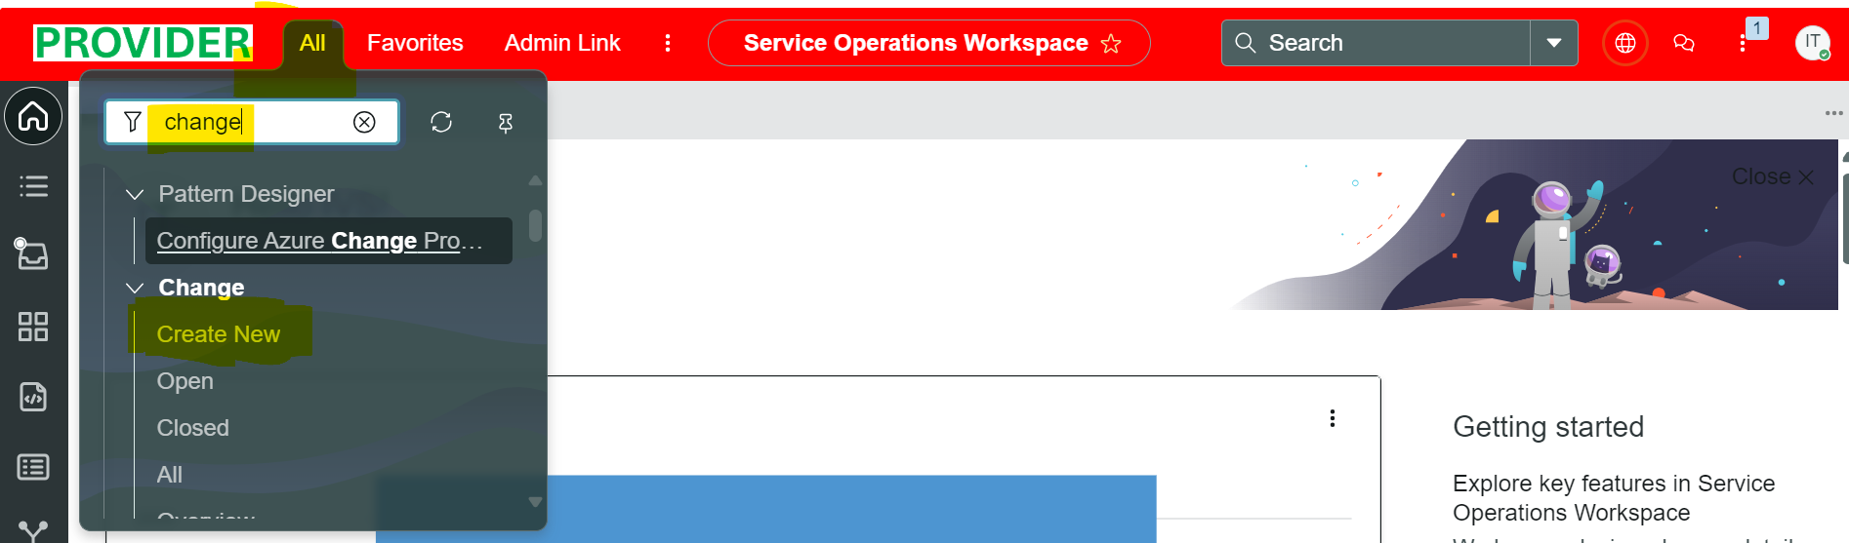

New change request form is opened

Fill all the required fields 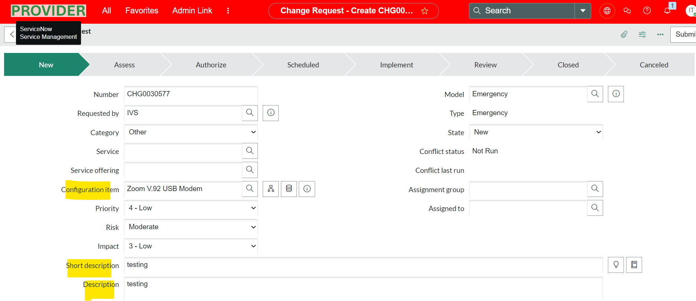

Save the form 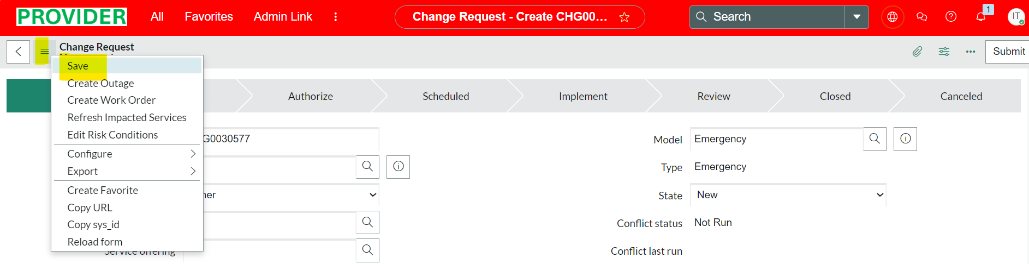

Change record is created successfully > Validate the type field value is ‘Emergency’ and State is ‘New’ 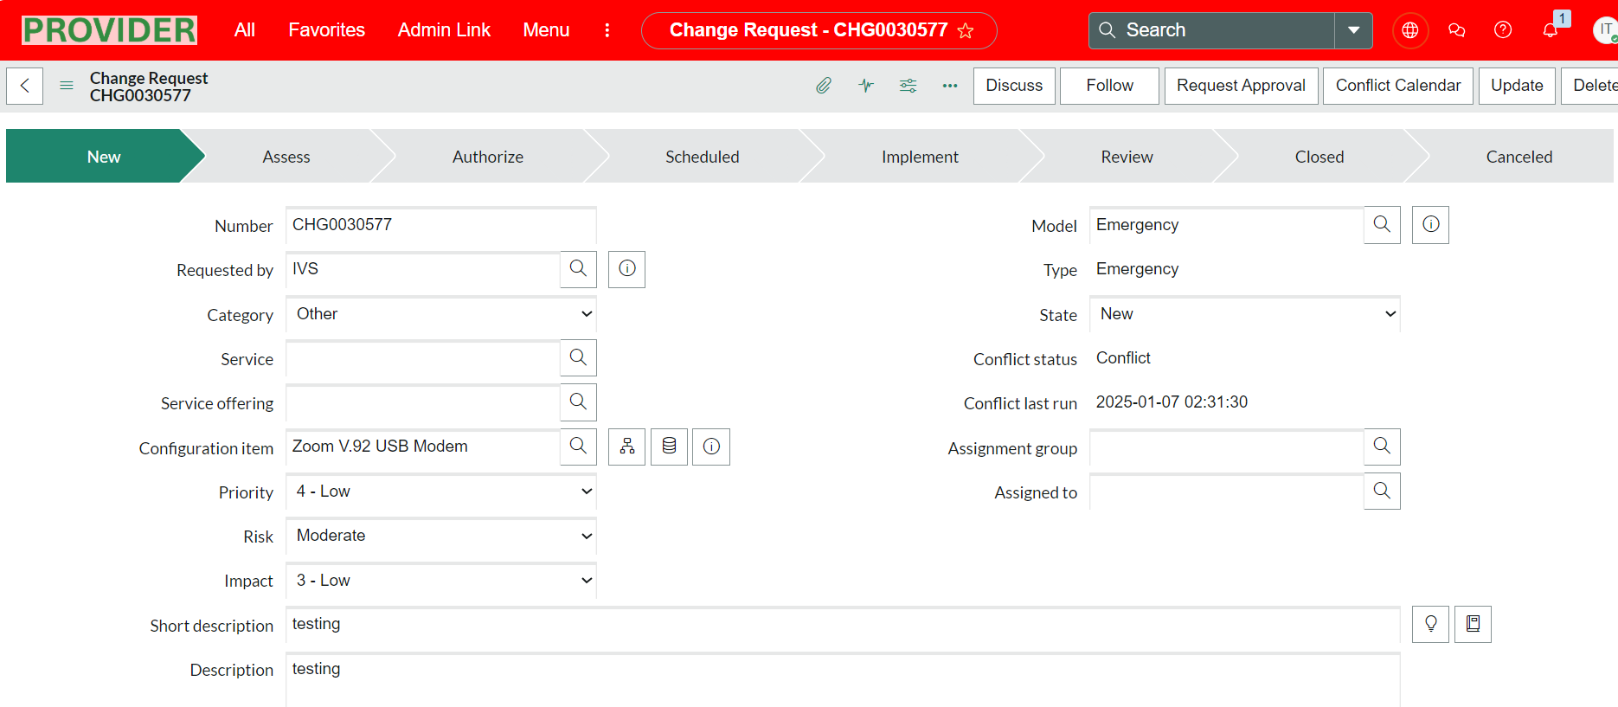

Click on ‘Request Approval’ UI Action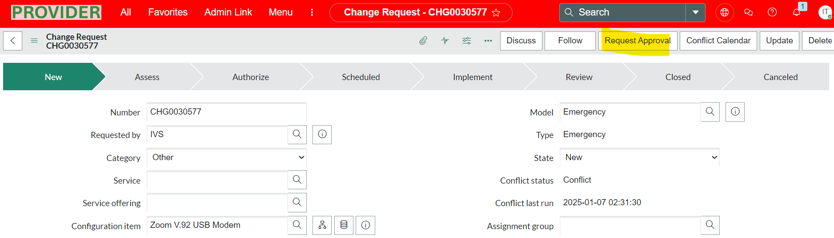

For approval of change request , we need to impersonate to any of the approvers from the above list and then approve

Here, I picked Bernard

Click on the user profile at the right top end of the banner and click on the Impersonate user, then search the user ’Bernard’ and select it and click Impersonate user

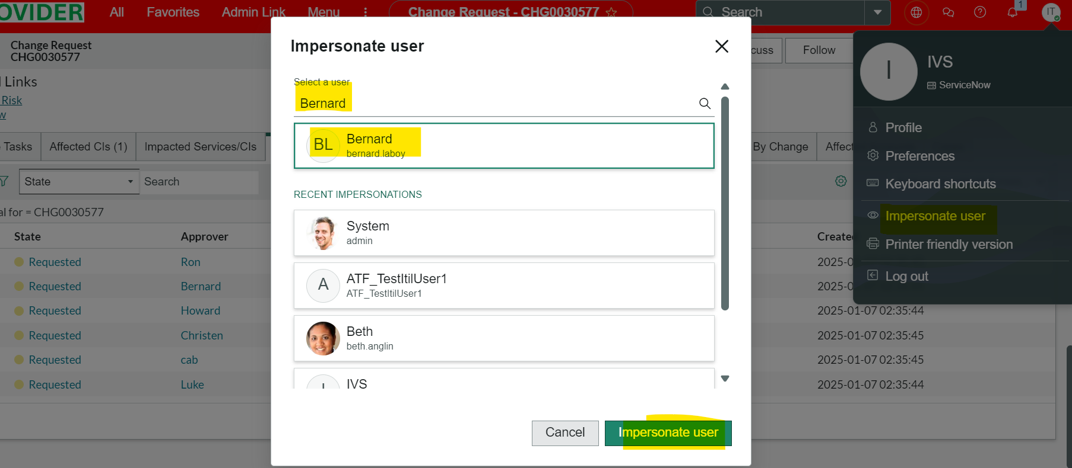

Navigate to ‘My Approvals’ table 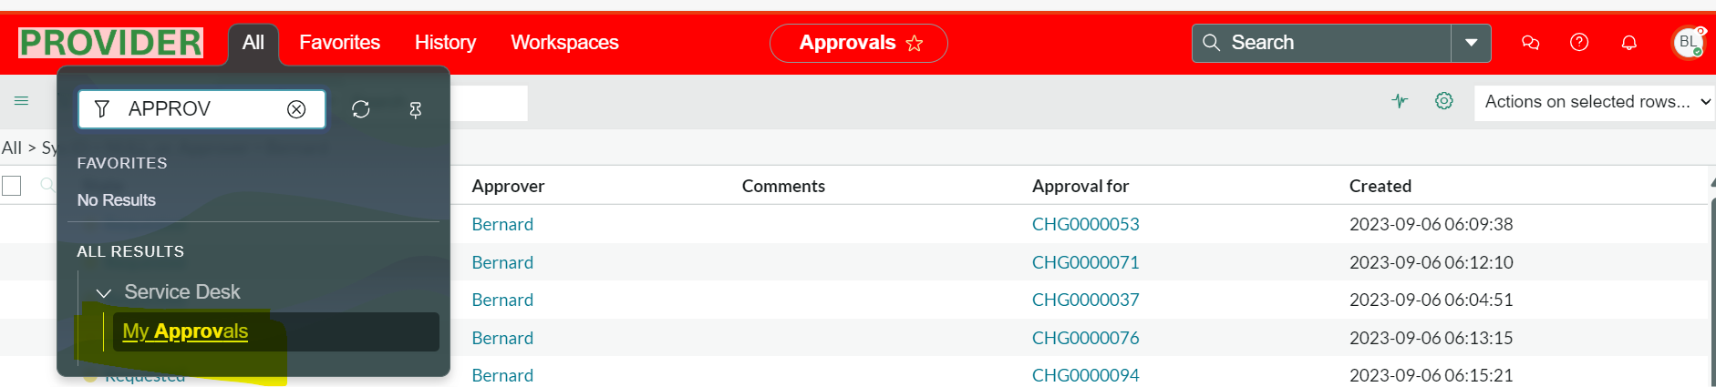

Search the change request we want to approve for

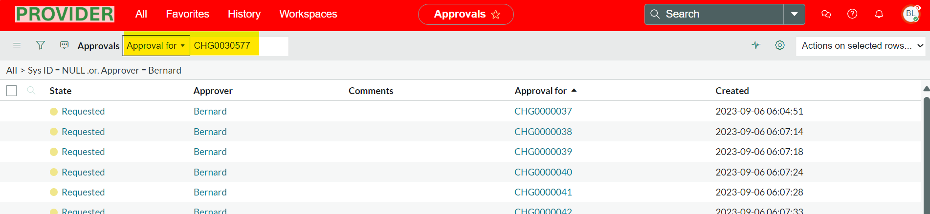

State is moved to Implement

Fill the assignment group , Planned start date, planned end date values and save the form 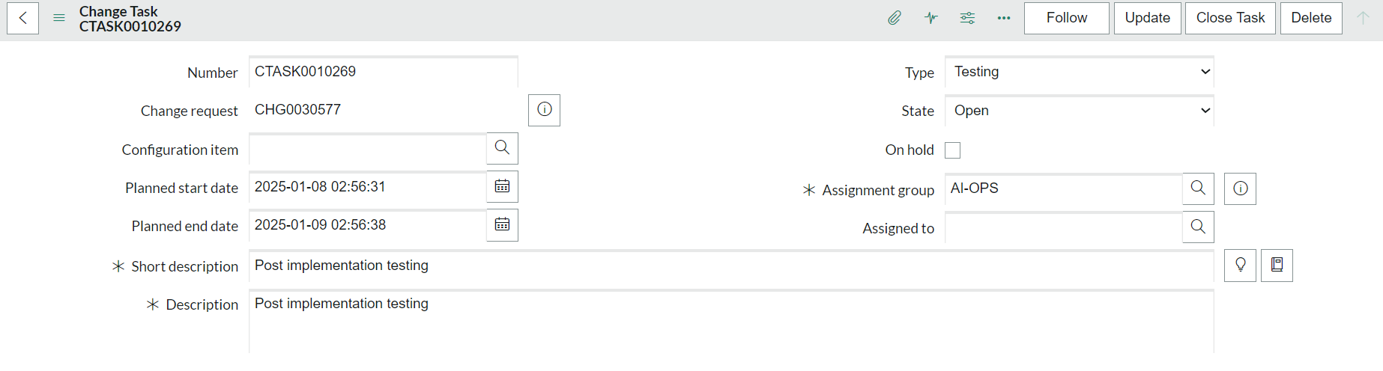

Fill close code and close notes and close task > change task is closed successfully

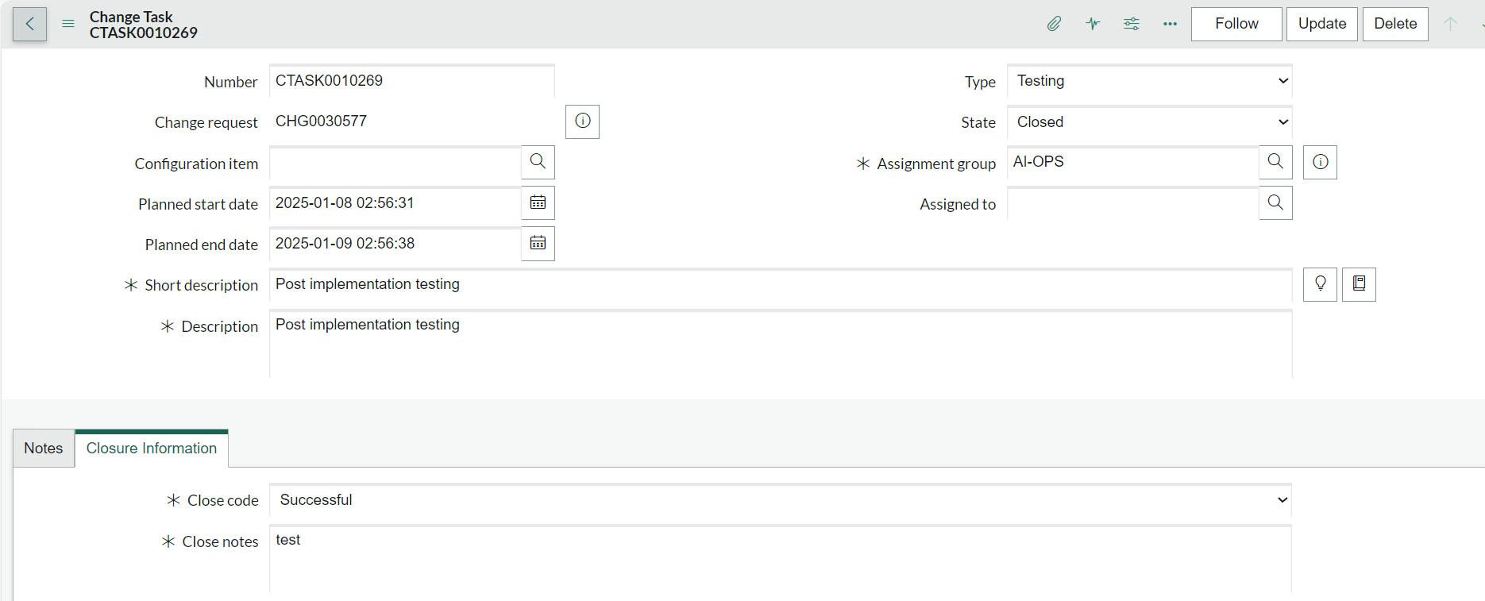

Fill close code and close notes and close task > change task is closed successfully

Fill mandatory close code and close notes and close button

